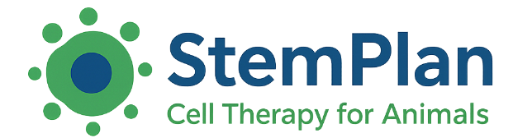
BioDivide Limited
24 Lysander Road
Melksham, Wiltshire
SN12 6SP, United Kingdom
Tel: +44(0) 1225 790 326
Email: Sales@BioDivide.com

StemPlan Canine
Autologous Adipose-Derived Stem Cell Therapy
Delivered from our UK ASCCA-licensed facility. Manufacturing and release overseen by the Responsible Person in accordance with ASCCA authorisation.
Defined Clinical Dosing
• One dose = 20 ± 2.5 million viable MSCs (per treated joint)
• Supplied in a sterile 2 mL depyrogenated injection vial
• Cryopreserved (≤ –70°C), defrost-ready for clinical injection
• 14-day sterility testing (USP FTB/TSB) prior to release
• Five years’ cryostorage included
Technology & Clinical Workflow
StemPlan provides culture-expanded, quantified MSC doses (not same-day SVF). Doses may be manufactured in advance and cryopreserved, allowing predictable scheduling without further adipose collection. Pricing is the same whether doses are produced from fresh adipose tissue or prepared from stored stem cells.
Pricing (ex VAT)
Item | Price
One Dose (per treated joint) | £895
Two Doses Manufactured in Same Batch | £1,350
Additional Doses Manufactured in Same Batch | £400
Cryobank Release (Stored Dose) | £425
A treatment consists of one dose per treated joint. Additional doses manufactured within the same batch may be administered during the same procedure or cryostored for future use. Collection kits, cryostorage and courier coordination are included at no extra cost.
Availability
• Approx. 4-5 weeks from receipt of adipose tissue
• Pre-manufactured doses available on demand
• Dose preparation from stored stem cells: approx. 3-4 weeks
StemPlan – Structured, Defined, Clinically Ready Autologous Therapy

